Warriors take on Vince Zavala Invitational

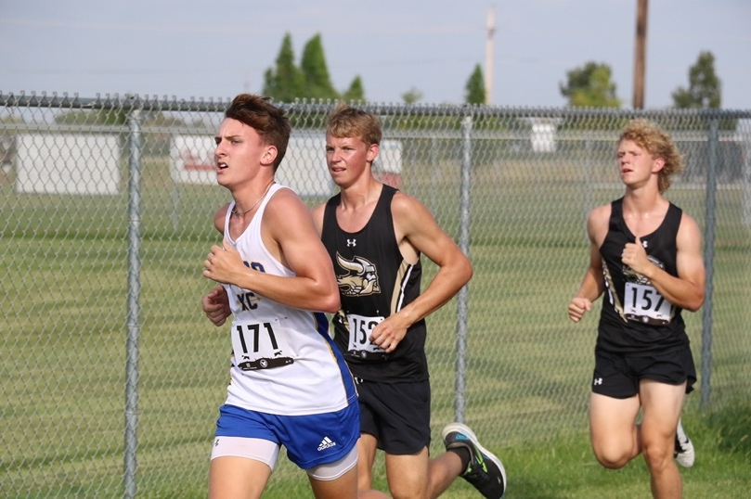
Alex Eller - Wahoo Newspaper - Aug 31, 2023

GRAND ISLAND — The Wahoo cross country team kicked off the 2023 season at the Vince Zavala Invitational at Grand Island Northwest on Aug. 25. In total, the Warriors finished with three medalists at the meet.
Ellie Warford led Wahoo with the top finish in sixth place overall with a time of 18:08.63 in the girl’s gold race. Coming in 14th overall was Aaralyn Dunlap, who posted an 18:49.49.
For the Warrior boys, Ales Adamec battled to an 11th place finish and got to the line in a time of 15:02.05. Three spots back in 14th overall was Logan Kleffner who ran a 15:16.61.
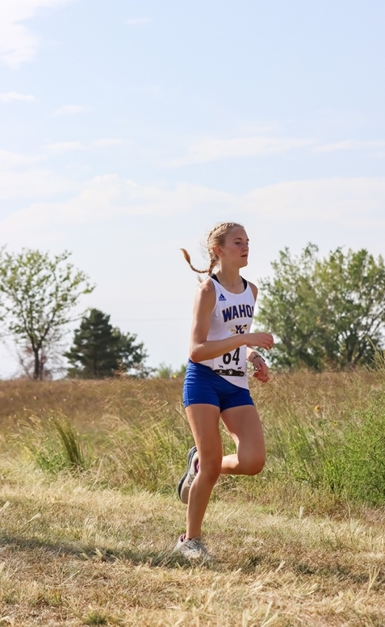
Next through the line for Wahoo was Madden Dwerlkotte, who clocked a 16:15.03 followed by Keegan Brigham in 28th place in a time of 16:19.29.
Patrik Adamec rounded out the runners for the Warriors boy’s by getting 39th overall by running a 17:01.07.
Competing in the junior varsity race for the Wahoo girls were Addisyn Darling, Anica Gannon and Mackenzie Chadwell. Darling got 17th place and posted a 22:47.88, Gannon ended up in 18th place and ran a 23:08.71 and Chadwell took 30th place and got to the line in 24:52.68.
Anthony Maple was the lead runner for the Warriors in the boy’s junior varsity race with a time of 16:44.86 in seventh place and Logan Lihs took 17th place and clocked a 17:25.44.
Earning 31st and 35th place were Chandler Beasley and Tatum Nelson who ran an 18:22.73 and an 18:42.12. Right behind them was Christopher Johnson and William Mortensen who clocked a 19:12.31 and a 19:31.10.
William Mortensen rounded out the scoring by getting 43rd and posting a 19:31.10.
Next up for the Warriors is the Schuyler Invite on Aug. 31. Due to the expected heat, the time for the meet has been pushed up to 11 a.m.

Area XC Results: Wahoo boys reign victorious at Schuyler Invite

Alex Eller - Wahoo Newspaper - Sep 7, 2023

Top of Form
Bottom of Form
Schuyler Invite SCHUYLER — Six runners inside the Top 20 helped the Wahoo Boys cross country team win the Schuyler Invite with 28 points on Aug. 31. That was 20 points in front of the second-place team Columbus Lakeview, which put up 48 points.
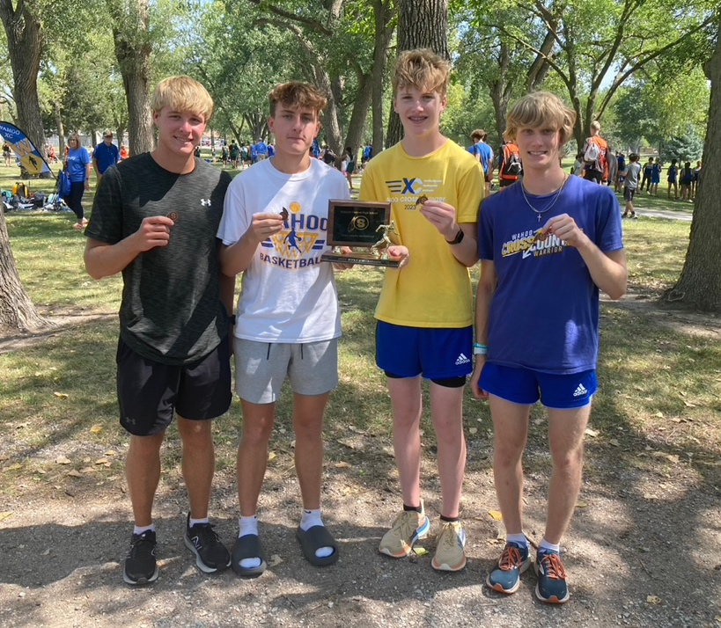
“The boys ran extremely well,” Wahoo head coach Bernie Nicola said. “They all had a strong start to the year and came in at fast times for this early. All are looking to improve on their times as we look at the upcoming season. I expect great things for this year.”
Leading the Warriors with a third-place finish with a time of 18:54.38 was Ales Adamec. That was followed closely by Logan Kleffner who got fifth by clocking a 19:05.67.
Coming in just under 20 minutes and posting a 19:55.72 to get 12th place was Keegan Brigham. Sliding just inside the Top 15 in 14th place was Madden Dwerlkotte after running a 20:02.02.
Rounding out the scoring for Wahoo were Anthony Maple and Patrik Adamec. Taking 17th place was Maple with a time of 20:13.34 and Patrik Adamec got 19th after posting a 20:26.14.
In the girls race, the Wahoo girls came in fourth place in a tough competition field with 51 points. Winning the meet was Centennial who scored 37 points.
Ellie Warford was the top finisher for the Warriors by getting fourth place with a time of 22:13.29. Earning 11th place was Aaralyn Dunlap who ran a 23:45.58 and Erin Golladay got 15th place after clocking a 24:45.47.
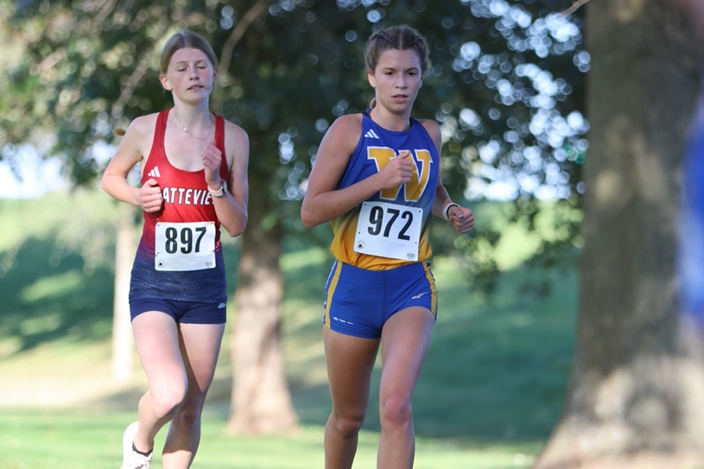
Back in 23rd place was Addisyn Darling who ran a 26:25.29 and Cadence Bailar ended up getting 30th place in a time of 27:33.23. Anica Gannon was the sixth runner for Wahoo in 32nd place after clocking a 27:44.17.
DC West Invite A solid run from Ben Lautenschlager powered the Bishop Neumann boys cross country to a seventh-place finish with 101 points at the Douglas County West Invite on Aug. 31. Back in ninth place was Yutan, which put up 123 points while Gretna East won with 41 points.
Coming in fifth place and finishing as the only medalist from the area was Ben Lautenschlager. The junior worked hard to keep up with the lead pack and ended up running a time of 18:26.20.
“Ben Lautenschlager had a great run,” Bishop Neumann head coach Taylor Schlautman said. “He worked hard this summer, so it’s great to see that pay off for him.”
Getting 16th place with a time of 19:37.21 was David Hart and Sebastian Lautenschlager posted a 21:47.71 to get 38th place.
Coming in back-to-back in 45th and 46th place were William Hart and Gabriel Fritsch with times of 22:17.90 and 22:18.27. Taking 49th and getting sixth for the Cavaliers was Luke Sylliaasen who ran a 23:05.19.
Ending up in 19th place and running a 19:52.52 was Bryce Kolc and Eli Kult took 25th place with a time of 20:30.07. In 32nd place was Justin Felty who clocked a 20:49.46 and Gage Kolc took 51st place in a time of 23:19.53.
On the girl’s side, Sofia Schoeneck of Neumann got 24th place by running a 27:24.88 and Madi Ledden of Yutan ended up in 32nd place and clocked a 28:55.45.
Beatrice Invite Against a solid fleet of competition, the Raymond Central Boys and Girls Cross Country Teams finished in 7th place at the Beatrice Invite on Sept. 2. The Mustang girls ended up with 140 points and the boys had 148 points.
The highest finisher for Raymond Central at the meet was Landon Lubischer in 26th place with an 18:47.19 on the boy’s side. Sam Norlen ended up getting 52nd in a time of 20:01.50 and Cole Dubas took 54th and posted a 20:08.35.
Earning fourth place for the boy’s team and getting 120th place overall was Deacon Christensen who ran a 24:32.06. Back in 128th and 135th place were Sean Shultz and Ethan Norlen who posted times of 26:15.35 and 26:50.28.
Isabelle Soden was the top finisher for the Mustang girls in 63rd place after clocking a 29:20.89. Brooke Munford, Olivia Svoboda and Morghan Schultz took 71st, 72nd and 73rd and ran a 32:30.37, 32:32.69 and a 33:04.50.

Competition heats up at Wahoo XC Invite

Alex Eller - Wahoo Newspaper - Sep 13, 2023

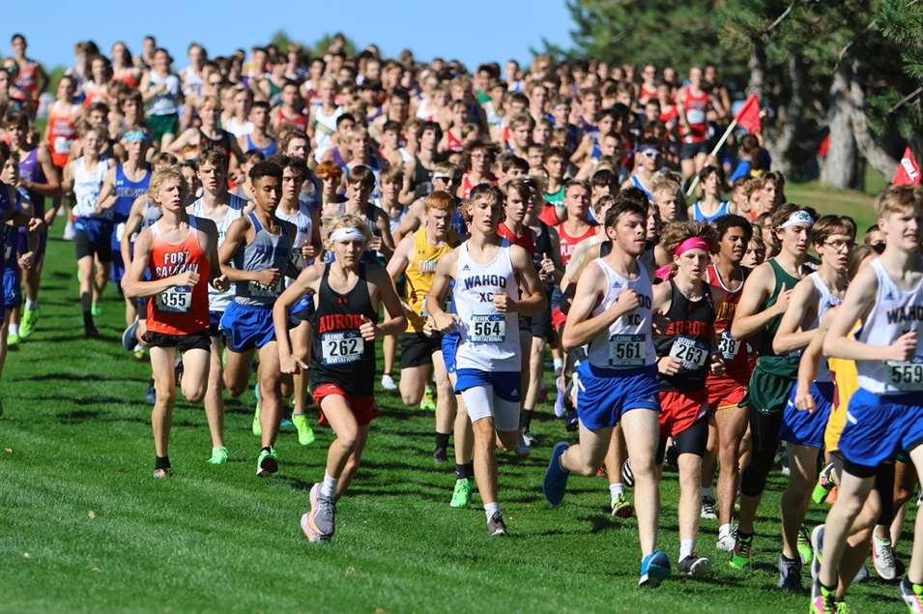
WAHOO — A tough field led to some great finishes at the Wahoo Cross Country Invite at Lake Wanahoo on Sept. 7. Three area schools that were in attendance were Wahoo, Bishop Neumann and Raymond Central.
Having the best finish of the area competitors were the Wahoo boys and girls teams. They came in third on the boys side and fourth on the girls with 58 points.
Leading the Warriors in the girls’ race was freshman Ellie Warford. She narrowly missed a top-five performance with a sixth-place finish in a time of 21:25.55.
Aaralyn Dunlap and Erin Golladay grabbed the last two medals of the varsity race in 14th and 15th place. Running a 23:17.08 was Dunlap, and Golladay clocked a 23:24.69.
Just under two minutes behind them was Cadence Bailar. The senior finished the three-mile course with a time of 25:22.26.
The final finisher for Wahoo in the girls’ race was Addisyn Darling who got 30th place and posted a 26:52.13.
Ales Adamec and Logan Kleffner were the two medalists for the Warriors on the boys’ side. Coming in ninth place was Ales Adamec in a time of 18:35.57 and Kleffner was right on his heels in 10th place running an 18:37.27.
Just outside the top 15 in 16th place was the senior Keegan Brigham, who ran a 19:11.09, followed by Madden Dwerlkotte in 23rd place with a time of 19:38.31.
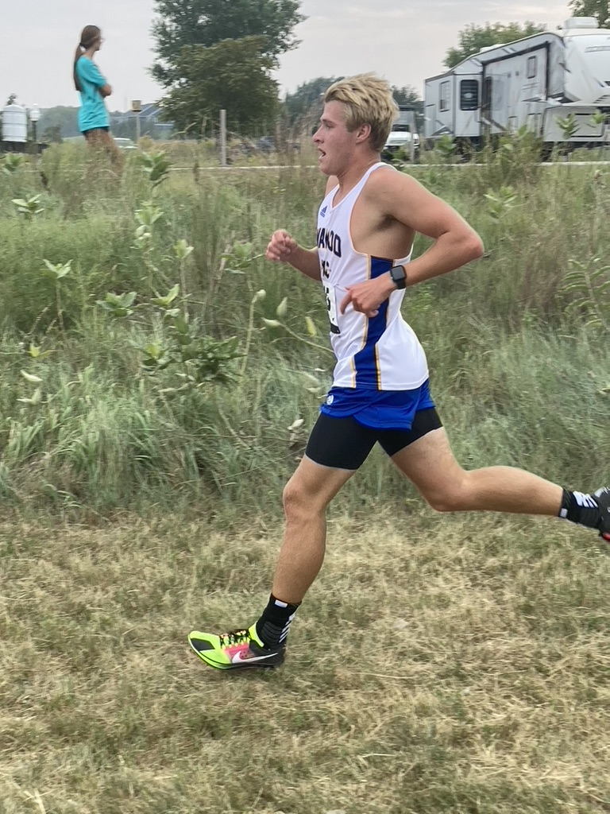
Rounding out the team score for Wahoo were Anthony Maple and Patrik Adamec in 33rd and 34th place. Maple ended up posting a 20:24.32 and Patrik Adamec ran a 20:32.74.
For Raymond Central, they were led by their boys team with a fifth-place finish with 84 points. The girls ended up getting sixth with 112 total points.
Landon Lubischer had the top finish for the area in the boys’ race by getting sixth place. The junior got to the line in 18:12.16.
Also medaling for the Mustangs was Cole Dubas in 12th place after running an 18:56.57. Ten spots back in 22nd was Sam Norlen who got to the line in a time of 19:37.19.
Deacon Christensen and Sean Shultz were the fourth and fifth runners for Raymond Central. Taking 44th place in a time of 23:35.48 was Christensen and Shultz ended up getting 45th place after posting a 26:53.19.
Pacing the Mustangs on the girls’ side was Olivia Svoboda in 22nd place in a time of 25:12.21. Isabella Soden was next through the line in 32nd place after running a 29:03.43.
Jacey Hofpar, Ellie White and Morghan Shultz came in 34th, 35th and 36th place in a time of 30:17.40, 30:34.15 and 30:39.38.
Taking home an eighth-place finish in the boy’s team standing was Bishop Neumann with 114 points. The girls did not have enough for a team score with only two runners.
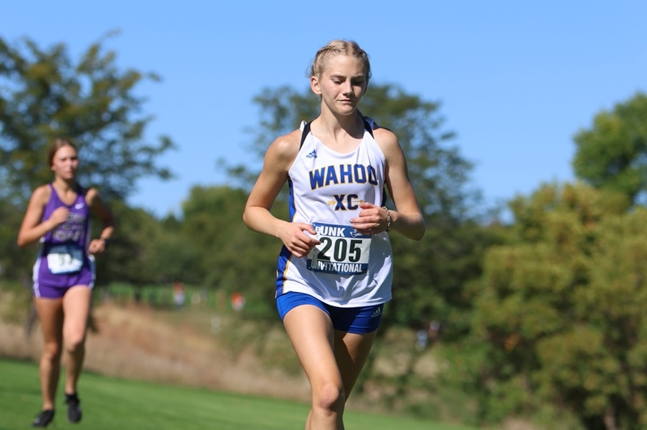
Ben Lautenschlager continues to have a good season for the Cavaliers and got seventh place in a time of 18:24.04. Finishing in 28th place and clocking a 19:58.93 was David Hart.
Running a 21:23.51 was Sebastian Lautenschlager and William Hart ended up getting 40th place by posting a 21:42.22. Earning a 42nd place finish was Gabriel Fritsch in a time of 22:25.56 and Ben Nagle took 43rd after clocking a 23:02.35.
Sofia Schoeneck led Neumann on the girl’s side by getting 26th place in a time of 25:41.81. Earning a 33rd place finish and running a 29:57.30 was Kate Jochum.
Wahoo, Raymond Central and Bishop Neumann will all be back in action again on Sept. 14. The Warriors and Mustangs run at 4:30 p.m. at the Columbus Scotus and Bennington Invites and the Cavaliers compete at 4 p.m. at the Ashland-Greenwood Invite.

Area XC Results: Warriors and Cavaliers battle at North Bend Invite

Alex Eller - Wahoo Newspaper - Sep 27, 2023

NORTH BEND — The Wahoo and Bishop Neumann cross country teams competed against a tough slate of competition at the North Bend Invite on Sept. 21. Coming in third in the boys’ team standings and fifth on the girls’ side were the Warriors with 67 and 81 points, and the Cavalier boys got seventh with 119 points.
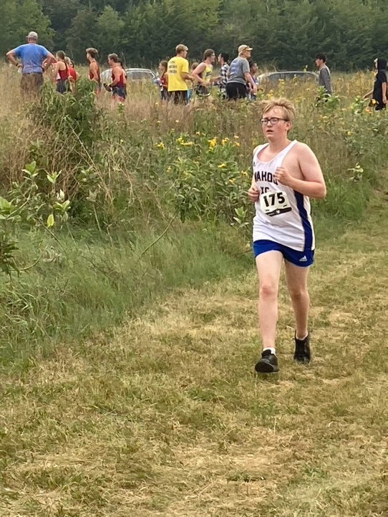
Leading the area in the girls’ race was Ellie Warford, who finished in second place. Her time for the three-mile course was 20:49.43.
“She has been continually improving her times throughout the year and is looking at securing her team a spot at state,” Wahoo Head Coach Bernie Nicola said. “Each girl is doing their part and working hard day in and day out. I couldn’t be more proud to watch these young ladies compete and enjoy what they are doing.”
Ending up 15 spots back in 17th place was Aaralyn Dunlap, who ran a 22:54.32. That was followed up by Erin Golladay, who clocked a 23:42.60 and got 25th place.
Coming in back-to-back in 41st and 42nd place were Cadence Bailar and Anica Gannon. Getting to the line in a time of 25:16.18 was Bailar, and Gannon ran a 25:21.02.
Isabelle Zelazny led the Neumann girls with a 27th place finish in a time of 24:07.86. Taking 49th overall was Sofia Schoeneck, who ran a 25:39.98, and Kate Jochum took 70th and ran a 29:13.81.
On the boys’ side, Logan Kleffner came in 10th place for Wahoo with a time of 18:20.02, followed closely by Ales Adamec, who took 13th place and clocked an 18:37.43.
Getting to the line in 20th place overall was Keegan Brigham who ran 19:10.52, and Anthony Maple came in 28th in a time of 19:44.15. Patrik Adamec and Madden Dwerlkotte clocked a 20:48.72 and 20:54.18 and finished in 38 and 42nd place.
Ben Lautenschlager was the only medalist for Neumann boys in 15th place with a time of 18:41.76. Taking 21st place was David Hart, who ran a 19:22.22.
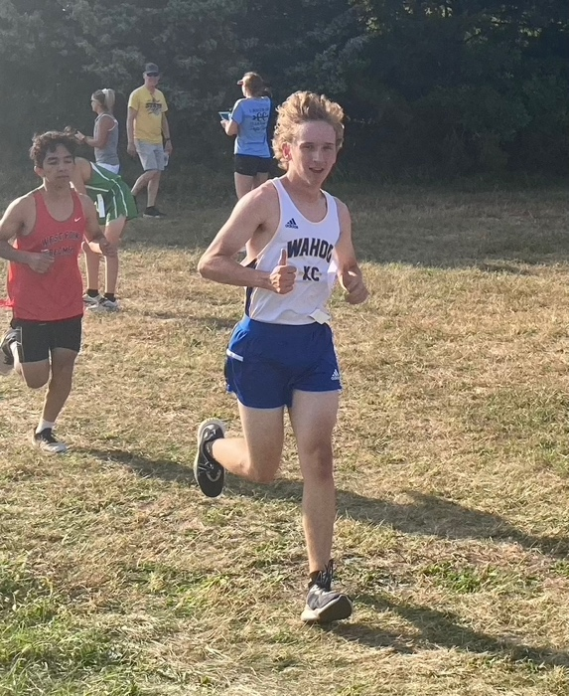
Hitting the finish line close together in 43rd and 46th place were Sebastian Lautenschlager and William Hart. Clocking a 20:48.72 was Sebastian Lautenschlager and William Hart ended up getting 46th in a time of 20:54.18.
Stryker Youngblood and Luke Sylliaasen were the final two finishers for the Cavaliers. Earning 54th place and running a time of 21:18.51 was Youghblood and Sylliaasen ended up getting 61st and clocked a 21:38.32.
Winning the team standing for the girls was Pender with 30 points, and Aquinas Catholic was second with 67 points. Omaha Roncalli was the boys’ team champion scoring 44 points, and Schuyler earned second with 65 points.

Fort Calhoun Invite
Boys Team Standings: 1. Fort Calhoun, 44 points; 2. Arlington, 52 points; 3. Papillion- La Vista South, 72 points; 4. Platteview, 85 points; 5. Minden, 91 points; 6. Louisville, 176 points; 7. DC West, 182 points; 8. Yutan, 206 points
Yutan Boys Finishers: 35. Bryce Kolc, 19:51.90; 39. Justin Felty, 20:30.70; 42. Eli Kult, 20:51.90; 49. Ethan Eggen, 22:08.60; 53. Gage Kolc, 23:24.10
Yutan Girls Finishers: 38. Madi Ledden, 28:01.80

Malcolm Invite
Boys Team Standings: 1. Lincoln Christian, 23 points; 2. Lincoln High, 46 points; 3. Aurora, 80 points; 4. Syracuse, 81 points; 5. Milford, 97 points; 13. Raymond Central, 231 points
Raymond Central Boys Finishers: 25. Landon Lubischer, 18:20.10; 37. Cole Dubas, 19:00.14; 65. Sam Norlen, 20:08.61; 107. Deacon Christensen, 23:37.17; 112. Sean Shultz, 24:41.74
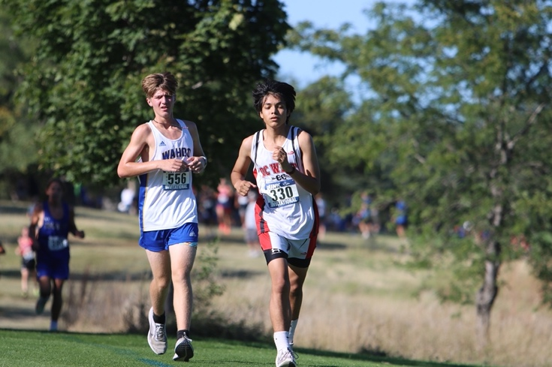
Girls Team Standings: 1. Columbus Scotus, 27 points; 2. Lincoln High, 57 points; 3. Aurora, 66 points; 4. Palmyra, 76 points; 5. Milford, 82 points; 14. Raymond Central, 259 points
Raymond Central Girls Finishers: 58. Olivia Svoboda, 26:17.70; 84. Jacey Hofpar, 29:00.51; 86. Isabella Soden, 29:21.69; 88. Morghan Shultz, 30:19.44

Cedar Bluffs Invite
Boys Team Standings: 1. Tri County, 18 points; 2. Fillmore Central, 21 points; 3. Wilber-Clatonia, 22 points; 4. Thayer Central, 27 points; Centennial, 53 points; 6. Cedar Bluffs, 62 points
Cedar Bluff Boys Finishers: 8. Graham Huffman, 18:44.47; 21. Nash Honeywell, 19:47.13; 46. Samuel Schmidt, 22:40.37; 60. Luke Schwarz, 29:59.80; 61. Tyler Story, 32:14.76

Area schools take on Nebraska-Kearney Invite

Alex Eller - Wahoo Newspaper - Oct 5, 2023

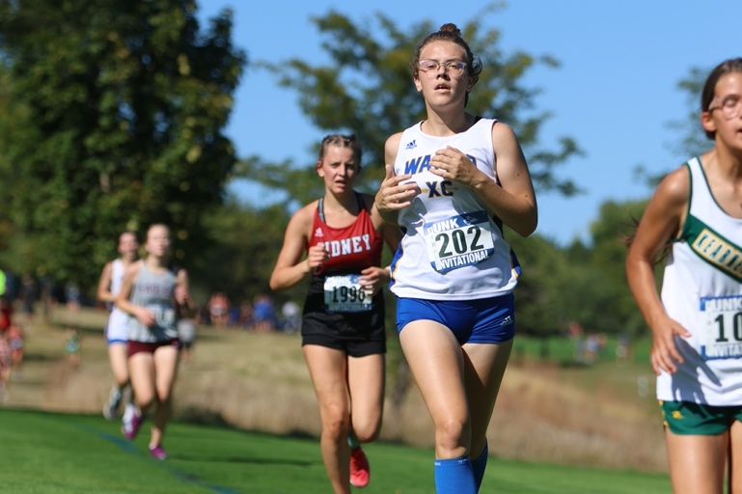
KEARNEY — The best runners from across the state descended upon the Kearney Country Club on Sept. 25 for the UNK Invite. Several teams from the area competed at the meet including Wahoo, Bishop Neumann and Yutan in the Class C race.

This course is the same one that the state meet will be held on at the end of October. It offers a unique challenge for even the most in-shape runner with mile after mile of rolling hills.
Coming through as the top finisher for the area was Ellie Warford of Wahoo in 33rd place. The freshman completed the three-mile course in a time of 22:33.44.
Ending up 16 spots back in 49th place was Aaralyn Dunlap for the Warriors who clocked a 23:26.41. That was followed by Erin Golladay in 65th running a 24:03.97, and Cadence Bailar posted a 25:46.61 to get 115th place.
Rounding out the team score for the Warriors were Anica Gannon, Addisyn Darling and Mackenzie Chadwell. They got 123rd, 161st and 187th clocking times of 26:03.07, 28:07.88 and 30:56.25.
For Yutan, Eva Georgoulopoulos was the first finisher in 128th place posting a 26:16.39. Taking 188th in a time of 31:24.76 for the Chieftains was Madi Ledden.
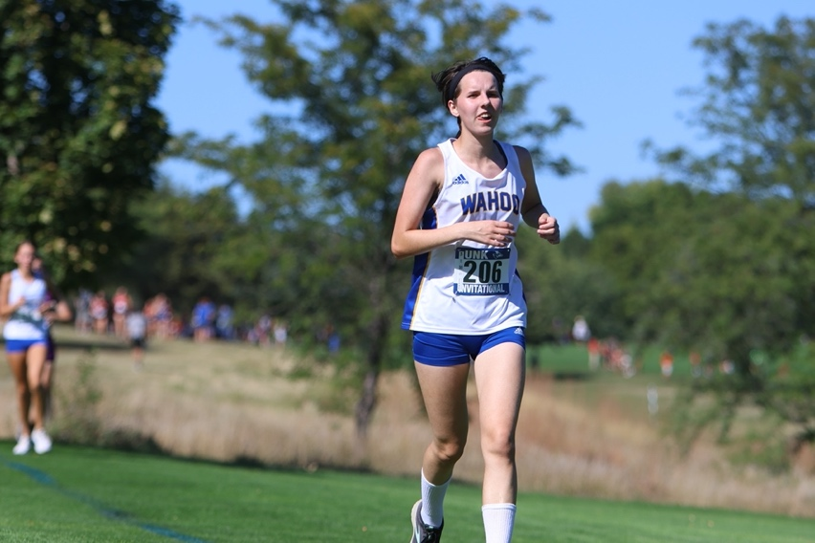
Logan Kleffner of Wahoo led the boys from the area with a solid 50th-place finish out of 339 runners. He crossed the line nearly a minute in front of the next runner from the area in 18:26.27.
The second and third runners for the Warriors were Ales Adamec and Keegan Brigham. Getting 94th place and clocking a 19:27.90 was Ales Adamec and Brigham earned 142nd place in a time of 20:14.54.
Madden Dwerlkotte and Anthony Maple came in 191st and 198th place overall. Running a 20:52.02 was Dwerlkotte, and Maple posted a 20:58.27.
Next to finish for Wahoo were Christopher Johnson and Patrik Adamec in 225th and 249th place overall in times of 21:28.82 and 22:09.31.
Ben Lautenschlager led Neumann in 99th overall after clocking a 19:32.65. Taking 148th place for the Cavaliers in a time of 20:24.01 was David Hart.
Pacing Yutan in 171st place and running a 20:41.14 was Bryce Kolc. Justin Felty and Eli Kult ended up getting 230th and 236th place and finished in times of 21:33.21 and 21:44.20.
Ethan Eggen and Gage Kolc were the final two finishers for the Chieftains in 293rd and 321st place.
Posting a time of 23:47.58 was Eggen and Kolc clocked a 26:00.47.
In the girl’s team standings, Wahoo got 12th place with 318 points. Winning the meet was Columbus Scotus who finished with 98 points and Auburn came in second putting up 135 points.
The Warrior boys ended up getting 25th place with 615 points, and Yutan took 36th place with 1,036 points. Tying atop the team standings with 87 points were Gothenburg and Lincoln Christian. Winning the meet were the Swedes by tiebreaker.
This week Neumann competed at the Centennial Conference Invite at Pioneer Park in Lincoln on Oct. 3.
Yutan and Wahoo will take part in the Capitol Conference and Trailblazer Conference Invites at 4 p.m. and 4:30 p.m. at Conestoga and Nebraska City on Oct. 5.

Wahoo puts together best performance at Conference Meet

Alex Eller – Wahoo Newspaper - Oct 11, 2023

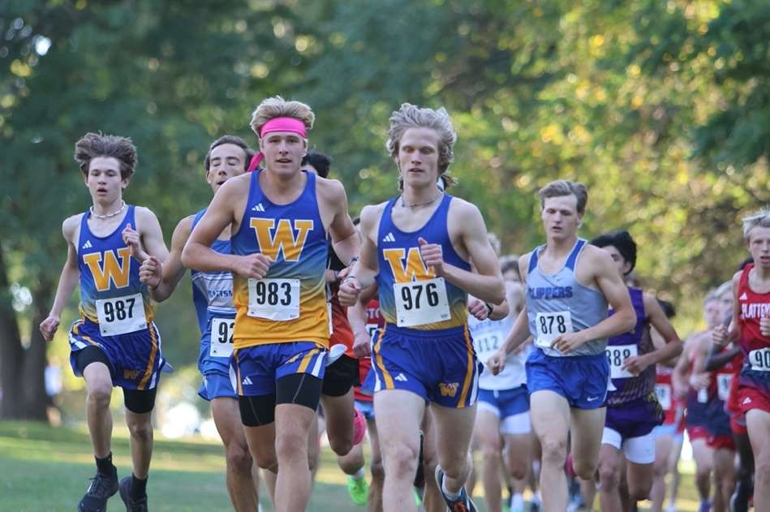
NEBRASKA CITY- Both the Wahoo boys and girls cross country teams put together some of their best performances of the season at the Trailblazer Conference Invite at Nebraska City on Oct. 5. The Warriors finished fourth in both team standings with the girls scoring 60 points and the boys putting up 74 points.
“The boy’s and girl’s teams both had their best races collectively as a team at Conference,” Wahoo Head Coach Bernie Nicola said. “The Trailblazer Conference has several fast teams and we competed right along with them.”
In the girl’s race, Ellie Warford and Aaralyn Dunlap both finished inside the top 15. Coming in fourth place was Warford in a time of 21:08.57 and Dunlap ended up taking 11th overall and clocked a 22:10.57.
Earning 24th and 25th place overall were Anica Gannon and Cadence Bailar. Getting to the line in 24:28.40 was Gannon and Bailar ran a 24:34.47.
Rounding out the scoring for the Warriors were Erin Golladay and Adisyn Darling. Running a 25:14.51 was Golladay and Darling ended up posting a 25:33.86.
Leading the boys for Wahoo was Logan Kleffner. The junior has cemented himself as the top runner for Wahoo after getting 12th place in a time of 18:07.86.
Five spots back in 17 place and running a 18:51.33 was Ales Adamec.
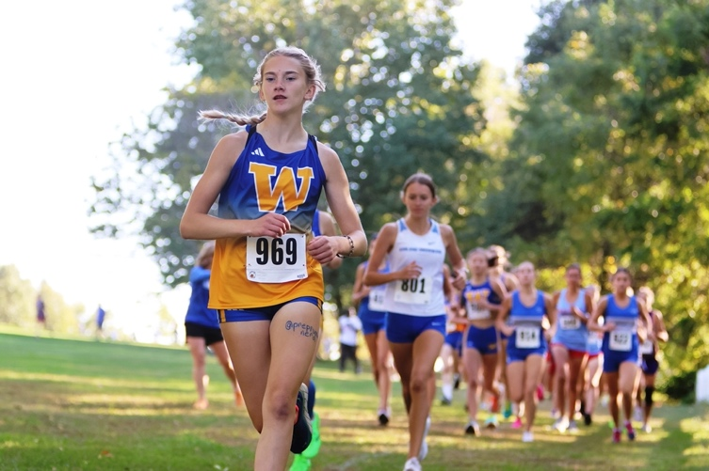
Coming in back-to-back in 22nd and 23rd place overall were Keegan Brigham and Anthony Maple. Clocking a 19:21.09 was Brigham and Maple ended up posting a time of 19:23.91.
Earning 30th place and running a 19:46.51 was Madden Dwerlkotte and Patrik Adamec clocked a 21:16.32 and got 37th place.
Winning the meet on the girl’s side was Plattsmouth who scored 25 points and Platteview took second with 28 points. Mallory Robbins of Plattsmouth won the individual gold with a time of 20:04.50 and Lydia Stewart of Platteview got second and ran a 20:24.89.
Plattsmouth was the top boys team in the conference with 22 points scored and Platteview came in second with 44 points. Running a 16:33.49 to win the boy’s race was A.J. Raszler of Platteview and Elijah Dixon of Plattsmouth was second in a time of 16:45.89.
This week Wahoo will be competing in the C-1 District Meet at 4:30 p.m. on Oct. 12 at Fort Atkinson State Park. The top 15 individual placers and three teams will qualify for the Class C State Cross Country Meet in Kearney.

Warriors qualify for the state meet as district runner-up

Alex Eller – Wahoo Newspaper - Oct 18, 2023

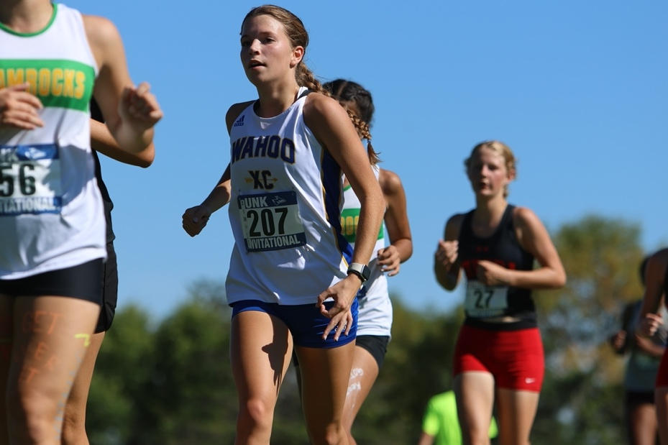
FORT CALHOUN — For the first time since 2019, the Wahoo girls cross country team is headed to the Class C State Cross Country Meet after getting second place with 50 points at the C-2 District Meet at Fort Atkinson State Park on Oct. 11.
Also qualifying for state was DC West, who was the district champion with 27 points, and Fort Calhoun was third with 57 points.
“Our girls have had the potential all season to do something great,” Wahoo Head Coach Bernie Nicola said. “Going into districts we knew that we had the opportunity to jump a spot and get ourselves to state by placing third. We motivated our girls by telling them that there was no pressure, to just run and just enjoy it and if they did that they would put themselves in that position. They really rose to the challenge and all of our runners; 1-6 ran extremely well.”
Pacing the Warriors with a third-place finish in a time of 20:43.85 was Ellie Warford. She was one of only three girls to break the 21-minute mark at the meet.
Coming in ninth place overall was Aaralyn Dunlap who posted a time of 21:57.91.
Also medaling inside the top 15 was Erin Golladay. The now two-time state qualifier got to the line in a time of 22:20.96.
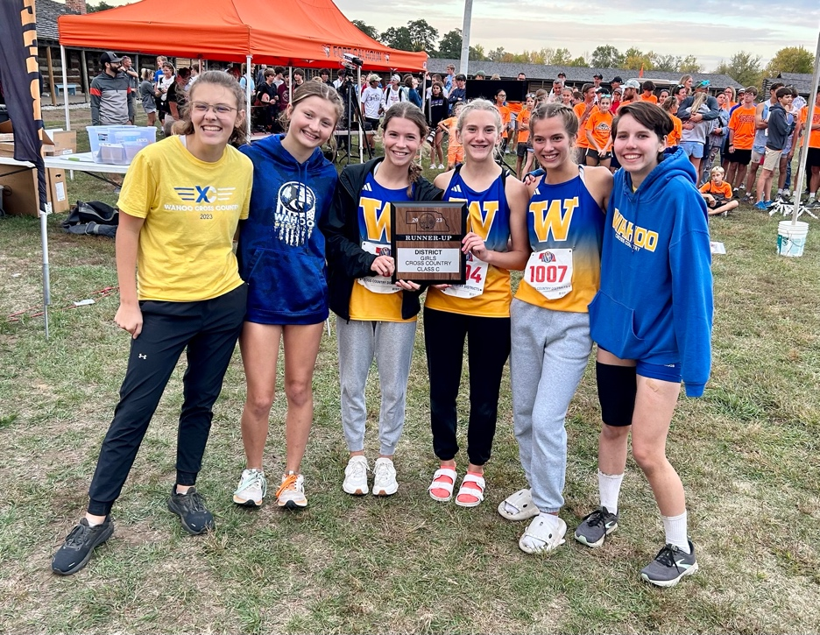
Anica Gannon was the fourth finisher for the Warriors after running a 23:47.83 to get 24th place. Back in 37th was Cadence Bailar who posted a 24:44.70, and Addisyn Darling was 38th after clocking a 25:30.79.
According to Nicola, he doesn’t want to put any pressure on the girls heading into state. He knows they are capable of great things and he looks forward to seeing how they do against the best of the best in the state.
“I think our goal for the state meet is very simple and it happens to be the same as our goal for districts,” Nicola said. “There is no pressure, just run, enjoy it and let’s see what the outcome is. Our girls are very capable of doing some great things come Friday.”
Over in the C-2 District at Branched Oak on the same day, Landon Lubischer of Raymond Central punched his first ticket to state by getting 14th place overall. He conquered the three-mile course in a solid time of 17:59.80
Teammate Colten Dubas just missed out on a spot at state by getting 17th place and running a time of 18:26.
“Landon worked his butt off to reach this state qualifying position,” Raymond Central Head Coach Elijah Hackbart said. “It was hard to see that Cole Dubas who was right next to him every practice not make it. I think he has a lot of potential to get top five next year if he works at it.”
At the D-1 District Meet at Cass County Fairgrounds on Oct. 12, the Cedar Bluffs Cross Country Program made history with its first state qualifier since bringing back the program three years ago. Earning that trip to state was Graham Huffman who came in 13th place overall after posting a time of 18:11.80.
The State Cross Country Meet will be held at the Kearney Country Club on Oct. 20. Running at 3 p.m. in the Class C Girls Race will be the Wahoo girls followed by Huffman in the Class D Boys Race at 3:30 p.m. Lubischer will hit the course at 4 p.m. in the Class C Boys Race.

Strong showing by Warriors at State Cross Country Meet

By Alex Eller - Wahoo Newspaper - Oct 26, 2023

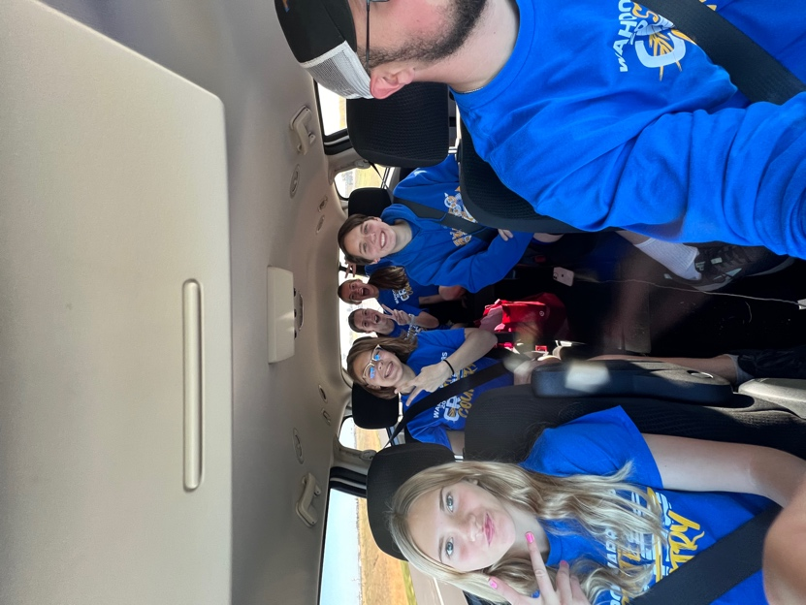
KEARNEY — The Wahoo Girls cross country team battled to a 12th place finish with 166 points in Class C at the State Cross Country Meet on Oct. 20 at the Kearney Country Club. Winning was Kearney Catholic, who put up 76 points, and Auburn was second with 80 points.
“I am super proud of them,” Wahoo Head Coach Bernie Nicola said. “We actually came out here earlier in the year for the UNK Invite, and it’s the same course. However, to actually race in this race, there is nothing like it.”
The top finisher for the Warriors was Ellie Warford in 18th place overall in a time of 21:54.90. That was followed by Aaralyn Dunlap who ended up getting 47th after running a 22:55.
Erin Golladay was the third-place finisher for Wahoo in 76th overall posting a 24:06.50. Taking 98th and clocking a 25:37.50 was Anica Gannon.
Rounding things out for the Warriors were Cadence Bailar and Addisyn Darling. Finishing in 101st was Baliar in a time of 25:49.90 and Darling was 108th after getting to the line in 27:10.40.
According to Nicola, he thought it was a good first step for Wahoo. He believes the Warriors will be back next year with five of the six runners returning off this year’s team along with some talented eighth graders coming up.
“I thought our girls had a super race,” Nicola said. “I know Ellie, our top finisher, was 18th which is right outside that Top 15 bubble. I expect a lot coming back next year at this point. I think they will come back with a lot of fire and will have a lot of success next year, too.”
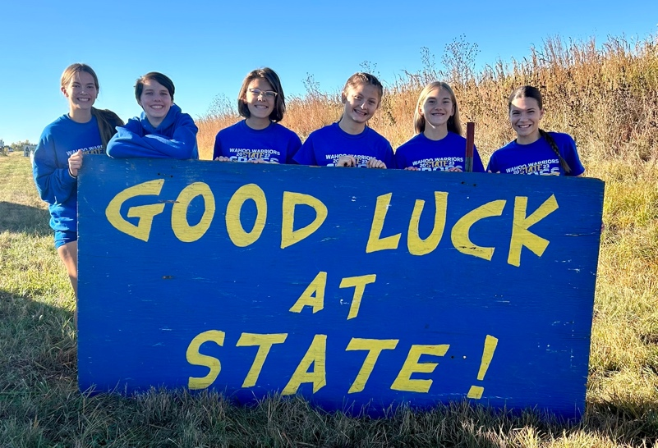
Competing in the Class C Boys Race for Raymond Central was Landon Lubischer. In his first state meet, the junior took 103rd place after posting a 19:57.30.
Graham Huffman of Cedar Bluffs took part in the Class D boys race in the second to last race of the day. He finished just inside the top 60 in 59th place with a time of 19:15.12.
“We are pleased that Graham earned the right to run at the state meet,” Cedar Bluffs Head Coach Greg Brousek said. “He, along with other runners in our program, put in a fairly solid summer of running out on the country roads.”
Winning the Class C Boys team standings with 38 points was Gothenburg, and North Platte St. Patrick’s was first for the Class D Boys after ending up with just 18 points.

Coach Nicola’s Season Recap

Another season is in the books and we can now reflect upon the success of the season. This year we had big changes to the team as last year we lost a lot of seniors. The younger group rose to the challenge with a many workouts, successes, and heartache along the way. As the year’s quote foretold, We Ran as One, Worked as a Team, and Finished as a Family.

Wahoo Front Runners

The 2023 season brought some new faces to the tops of the programs. Junior Logan Kleffner succeeded in establishing himself as the top boy runner. Logan placed in six or eight competitions for the year and looks for a trip to state during his senior year. Freshman Ellie Warford burst into the scene as a one of the top girl competitors in many years. She led her team to its first state birth in 4 years and earned a total of 8 medals in 10 competitions for the year.

Young…But Mighty

This year the team benefited from many top-notch runners from younger grades. There was a total of nine freshman and three sophomores on the team bringing with them new passion for running and competing. Our boys’ team has a wealth of fresh talent that is already pushing times that are close to some of the more senior athletes. Similar to the boys, our girls’ team put up some impressive times this year and it bodes well for the future. This year’s girls team saw its best three times come from this younger group.

Senior Spotlight

The 2023 season marks the final finish line for two athletes that have stuck it out through all the tough workouts and competitions. Keegan Brigham was elected Team Captain for the 2023 season and helped to lead his team to many individual successes. As the quiet leader, he led by action rather than words. His dedicated and determined mentality will be missed next year. Cadence Bailar was instrumental in the success of her team this year. The positivity of her personality was beneficial during many tough days. After battling through some injuries during her career, she truly gave it her all during her senior year.
Top 10:

This select group has obtained the lowest times through all competitions. The Top 10 Award is given to the five times of both boys and girls.

Boys:
- Logan Kleffner: - 18:07
- Ales Adamec – 18:35
- Keegan Brigham – 18:51
- Anthony Maple – 19:23
- Madden Dwerlkotte – 19:23

Girls:
- Ellie Warford – 20:43
- Aaralyn Dunlap – 21:57
- Erin Golladay – 22:30
- Anica Gannon – 23:47
- Cadence Bailar – 24:34

Looking Forward

The 2024 season will be a year to remember for the Wahoo Cross Country program. The boys will have 5 of the 6 varsity runners back with a burning desire to make it to state. The girls look to build upon their successes also with 5 of 6 varsity runners returning next year. High expectations have been set but the boys and girls will rise to the occasion. Our middle school runners have had huge success during the 2023 season and look to jump into the two programs during 2024. The days until next year have already begun counting down.

Run, Warriors, Run!

